4ITRC2 Operating System Lab

Lab Assignment 3

**Aim**: To create shell scripts for the following questions

**To perform**: To code and solve the following

**To Submit**: Give shell scripts for following:

1. To find Largest of Three Numbers

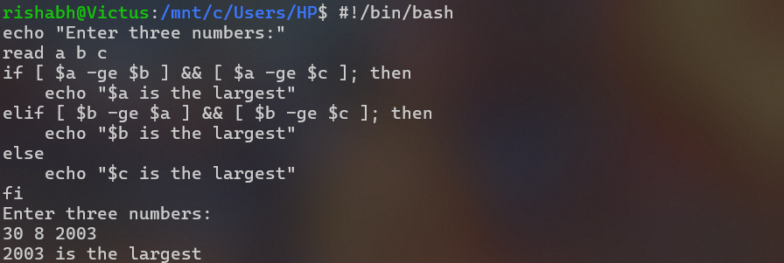

1. To find a year is leap year or not.

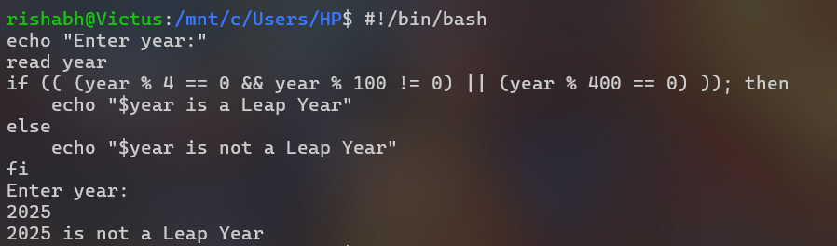

1. To input angles of a triangle and find out whether it is valid triangle or not

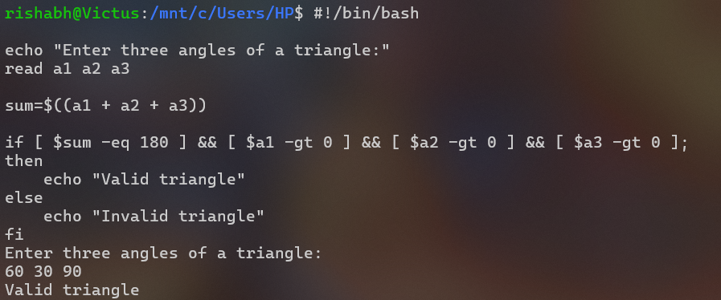

1. To check whether a character is alphabet, digit or special character.

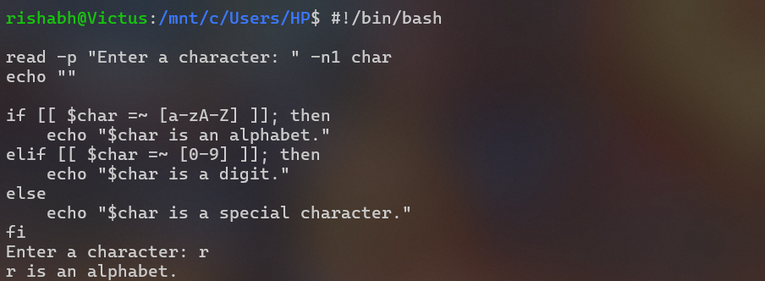

1. To calculate profit or loss

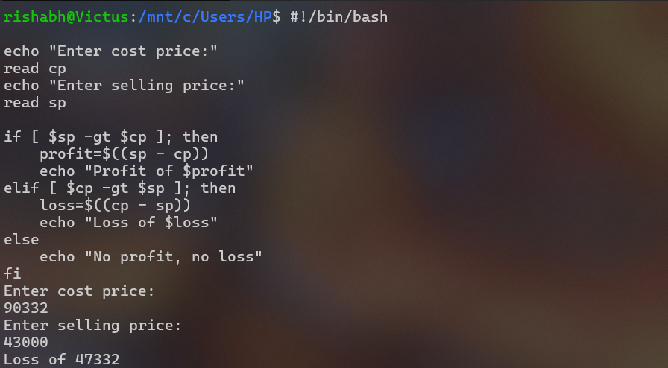

1. To print all even and odd number from 1 to 10

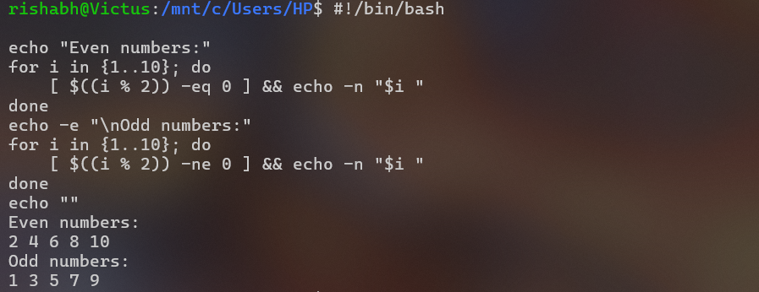

1. To print table of a given number

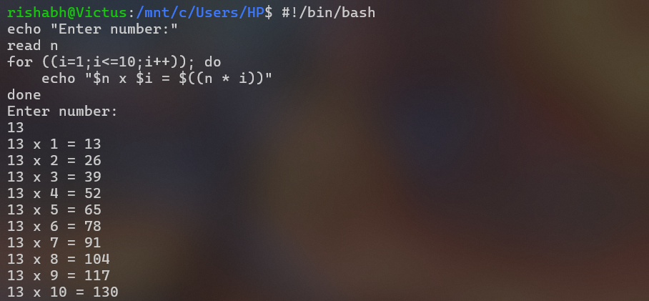

1. To find factorial of a given integer

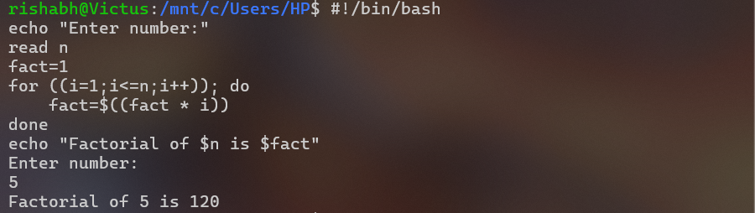

1. To print sum of all even numbers from 1 to 10.

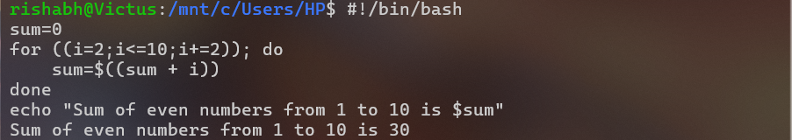

1. To print sum of digit of any number.

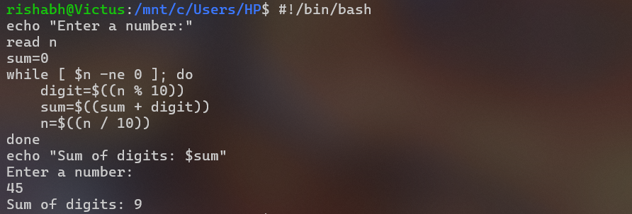

1. To make a basic calculator which performs addition, subtraction, Multiplication, division

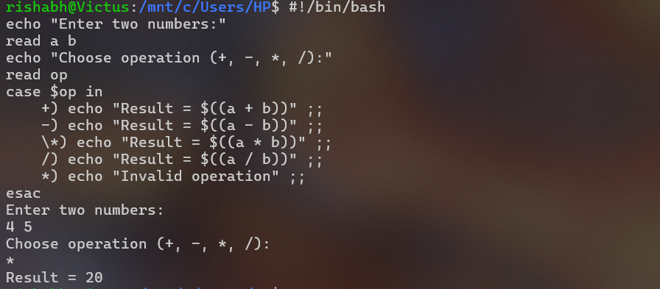

1. To print days of a week.

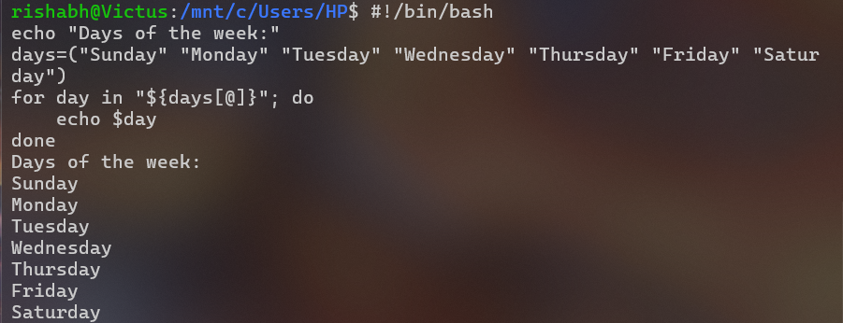

1. To print starting 4 months having 31 days.

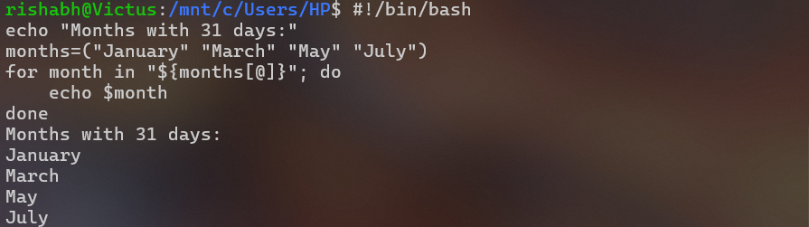

1. Using functions,
   1. To find given number is Amstrong number or not

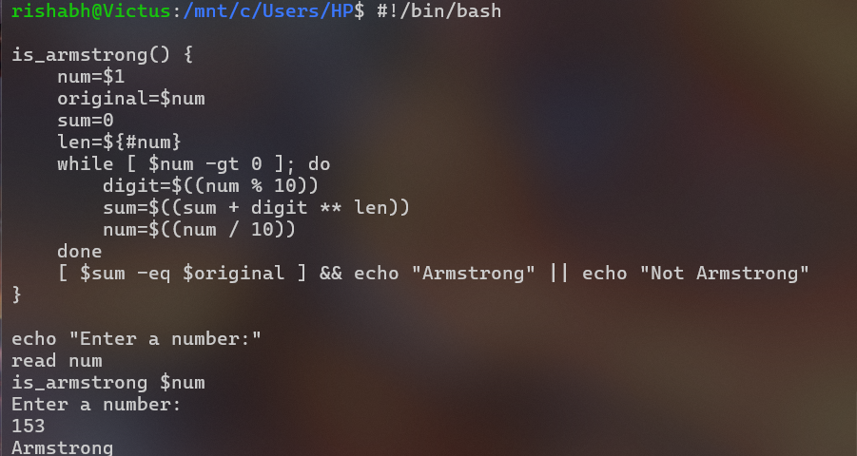

* 1. To find whether a number is palindrome or not

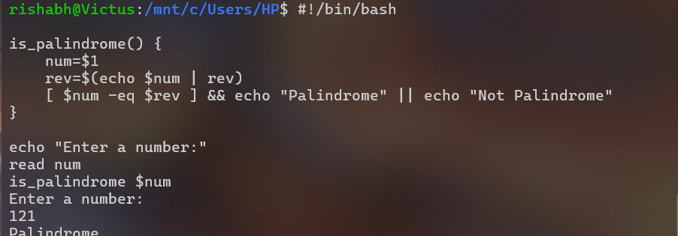

* 1. To print Fibonacci series upto n terms

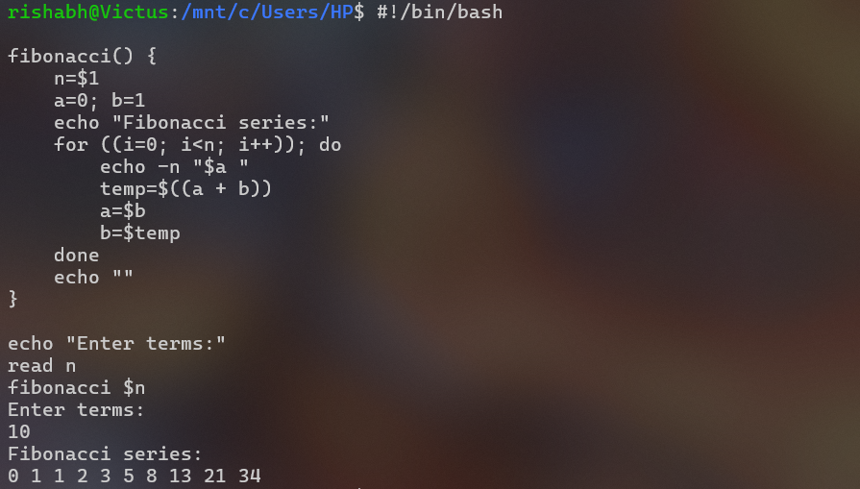

* 1. To find given number is prime or composite

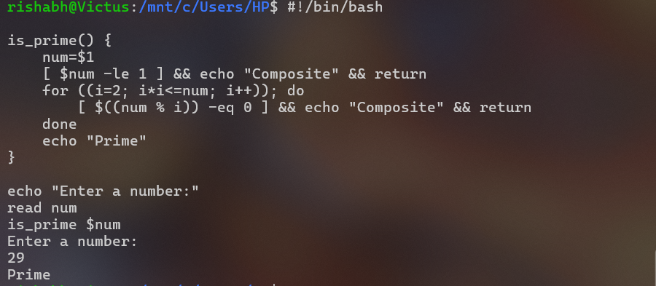

* 1. To convert a given decimal number to binary equivalent

